MARKING GUIDELINE
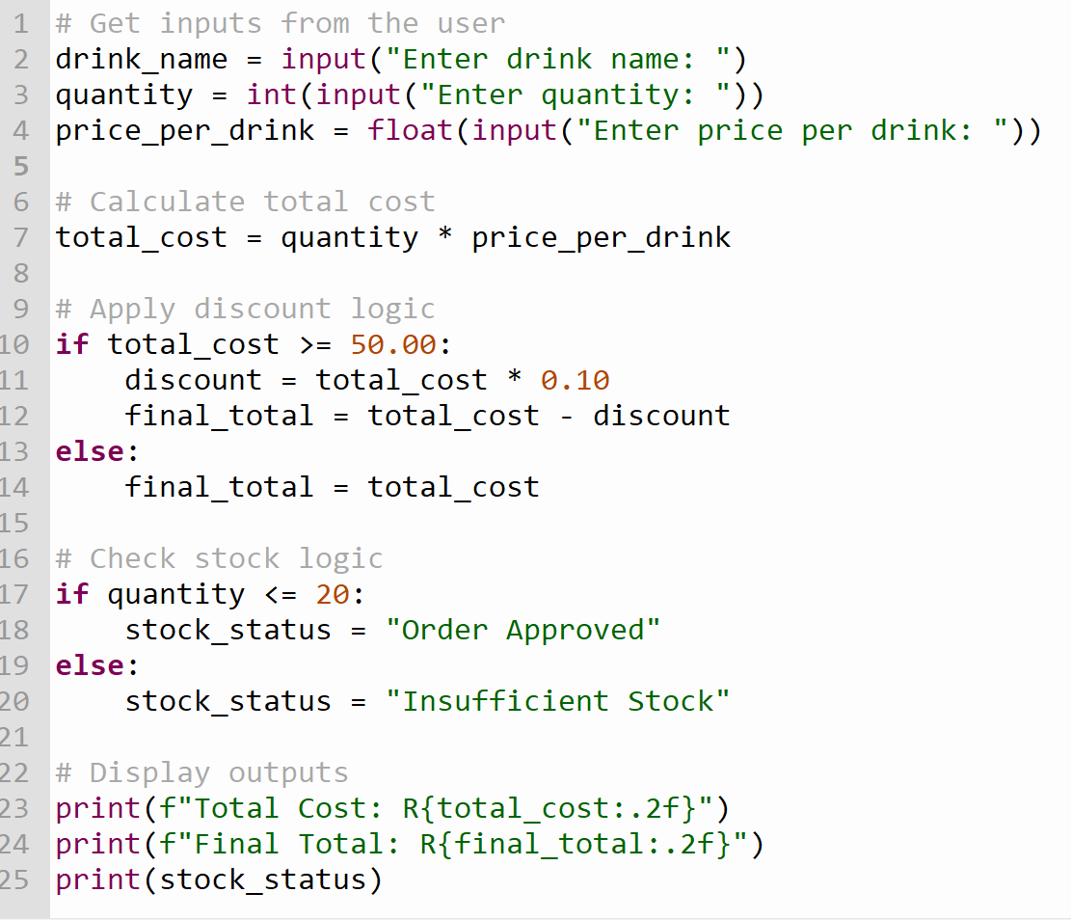

Marking Guide (30 Marks total, tied to outcomes)
Each mark is awarded once. The marker will run the 3 test data sets against the student's code.
Outcome 1: Input, Output, and Arithmetic (15 Marks)
- (3 marks) Correctly uses input() for all three variables (Name, Quantity, Price).
- (3 marks) Correctly converts the quantity input to an integer and price to a float.
- (3 marks) Correctly calculates the total_cost using multiplication.
- (3 marks) Outputs the Total Cost formatted correctly to 2 decimal places.
- (3 marks) Program runs without any syntax errors in Thonny.

Outcome 2: Conditional Logic (15 Marks)
- (5 marks) Correctly implements an if statement to check if the total cost is >= 50.00.
- (5 marks) Correctly implements the 10% discount calculation and subtraction, AND correctly handles the else scenario (no discount applied) as proven by Test Data 2.
- (5 marks) Correctly implements the nested/sequential logic to check if quantity is <= 20, correctly printing "Order Approved" or "Insufficient Stock" based on Test Data 3.

Reasoning Question
I used >= 50.00 because the scenario states that the discount applies if the total is "R50.00 or more". If I used > 50.00, a customer spending exactly R50.00 would not receive the discount. Using >= ensures inclusive logic, meaning exactly R50.00 qualifies for the 10% discount.

